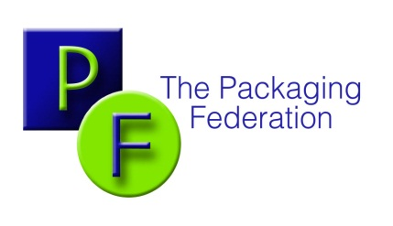

The Packaging Federation
8th Floor
64 Victoria Street
London
SW1E 6QP

Telephone: 020 7808 7217
Mobile: 07932 697151
E-mail:dicksearle@packagingfedn.co.uk
www.packagingfedn.co.uk

THE “FRESHER FOR LONGER” ANIMATED FILM

The film can be found on:

http://england.lovefoodhatewaste.com/content/fresher-longer-best-date

